11. **Scenario :** You are a data scientist working for a company that sells products online. You have

been tasked with creating a simple plot to show the sales of a product over time.

**Question:**

1. Write code to create a simple line plot in Python using Matplotlib to predict sales happened in a

month?

2. Write code to create a scatter plot in Python using Matplotlib to predict sales happened in a

month?

3. Develop a Python program to create a bar plot of the monthly sales data

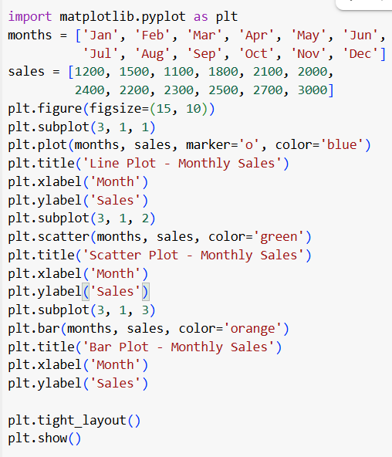 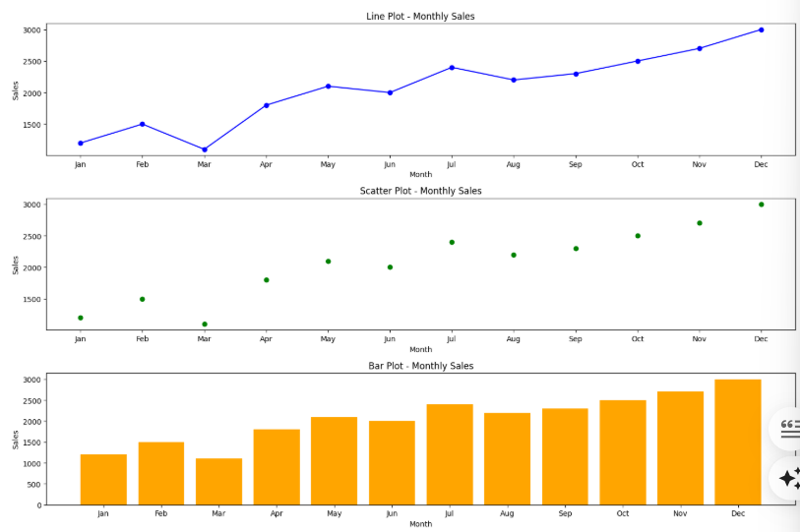

12. **Scenario:** You are working on a data analysis project that involves analyzing the monthly

temperature and rainfall data for a city. You have a dataset containing the monthly temperature and

rainfall values for each month of a year. Your task is to develop a Python program that generates

line plots and scatter plots to visualize the temperature and rainfall data.

**Question:**

1. Develop a Python program to create a line plot of the monthly temperature data.

2: Develop a Python program to create a scatter plot of the monthly rainfall data

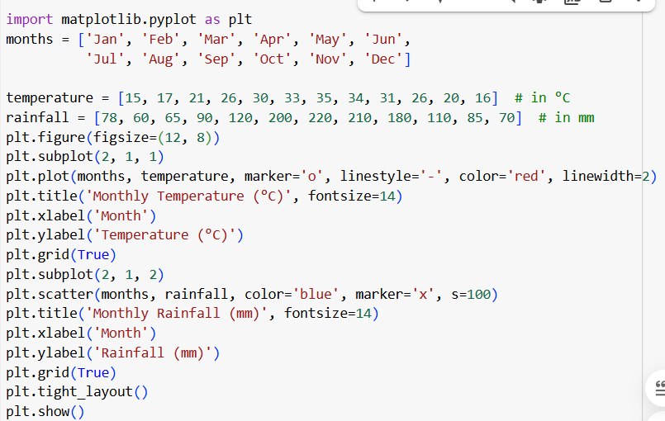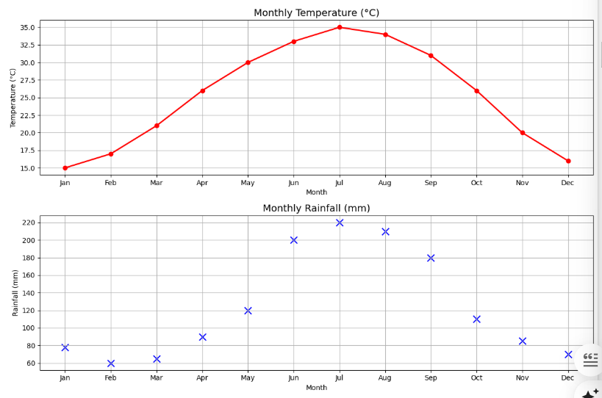

13. **Scenario:** You are working on a text analysis project and need to determine the frequency

distribution of words in a given text document. You have a text document named "sample_text.txt"

containing a paragraph of text. Your task is to develop a Python program that reads the text

document, processes the text, and generates a frequency distribution of the words.

**Question:** How would you develop a Python program to calculate the frequency distribution of

words in a text document?

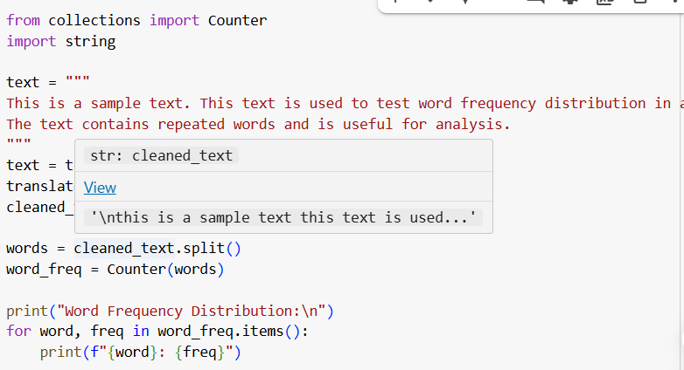 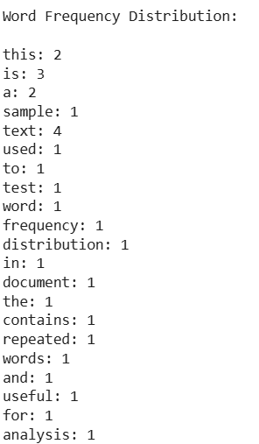

14. **Scenario**: You are a data analyst working for a company that sells products online. You have

been tasked with analyzing the sales data for the past month. The data is stored in a Pandas data

frame.

**Question:** Develop a code in python to find the frequency distribution of the ages of the customers

who have made a purchase in the past month

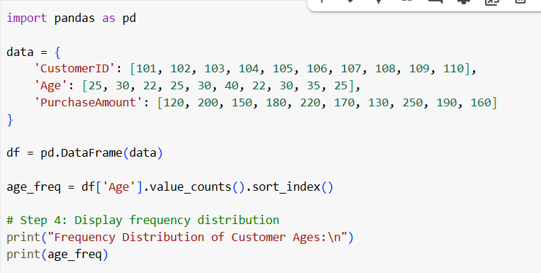 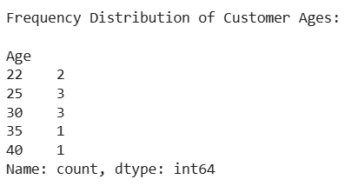

15. **Scenario:** You are a data analyst working for a social media platform. As part of your analysis,

you have a dataset containing user interaction data, including the number of likes received by each

post. Your task is to develop a Python program that calculates the frequency distribution of likes

among the posts.

**Question:** Develop a Python program to calculate the frequency distribution of likes among the

Posts?

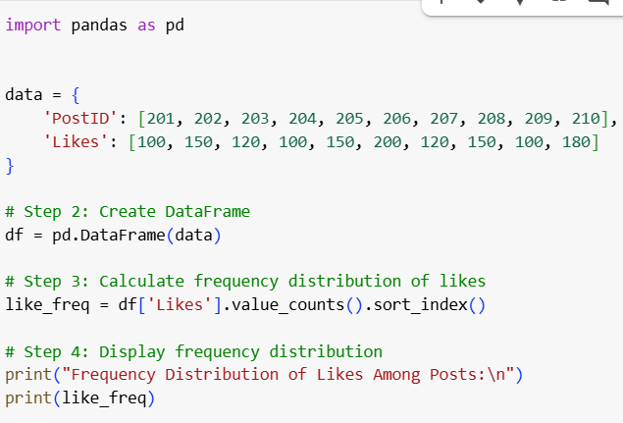 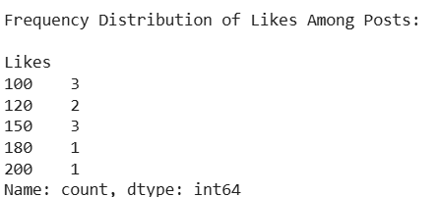

16. **Scenario:** You are working on a project that involves analyzing customer reviews for a product.

You have a dataset containing customer reviews, and your task is to develop a Python program that

calculates the frequency distribution of words in the reviews.

**Question:** Develop a Python program to calculate the frequency distribution of words in the

customer reviews dataset?

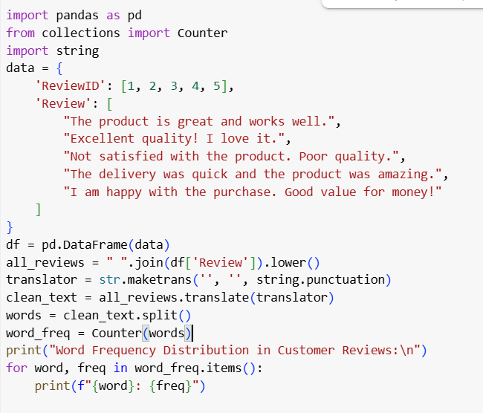 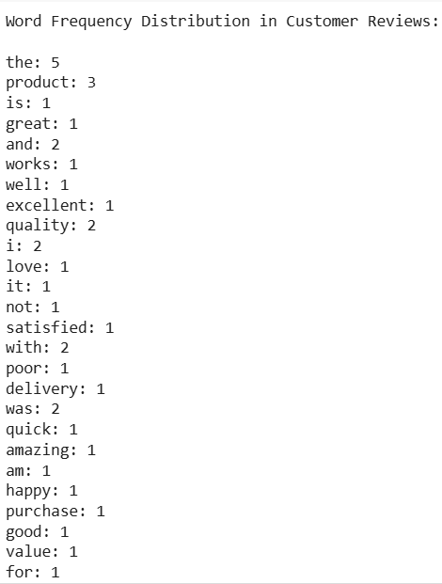

17. **Scenario:** You are a data analyst working for a marketing research company. Your team has

collected a large dataset containing customer feedback from various social media platforms. The

dataset consists of thousands of text entries, and your task is to develop a Python program to

analyze the frequency distribution of words in this dataset. Your program should be able to perform

the following tasks:

**Question**: Create a Python program that fulfills these requirements and helps your team gain

insights from the customer feedback data.

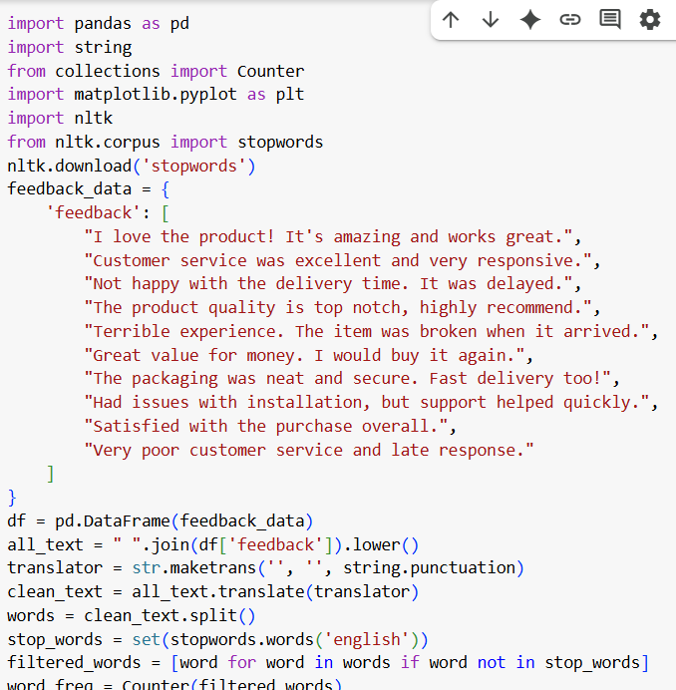 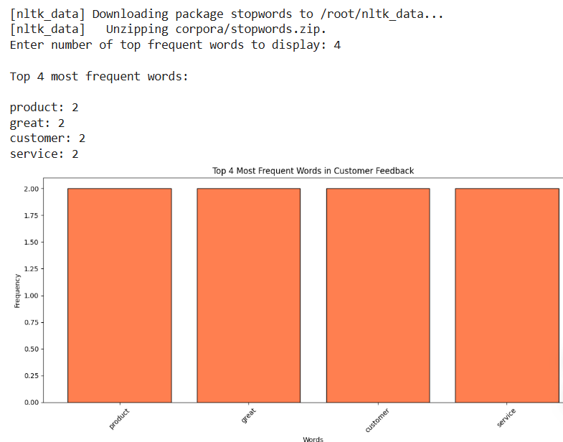

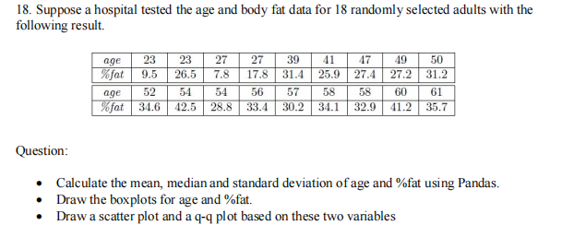

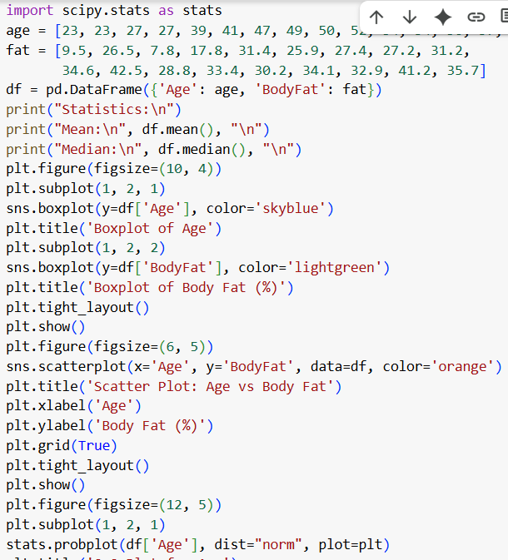 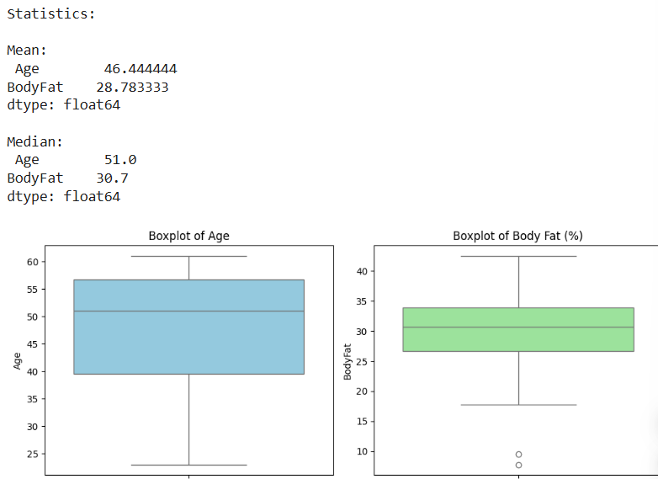

19. **Scenario:**

You are a medical researcher investigating the effectiveness of a new drug in reducing blood

pressure. You conduct a clinical trial with a sample of 50 patients who were randomly assigned to

receive either the new drug or a placebo **Question:** "What is the 95% confidence interval for the mean reduction in blood pressure for patients who received the new drug? Also, what is the 95% confidence interval for the mean reduction in blood pressure for patients who received the placebo?

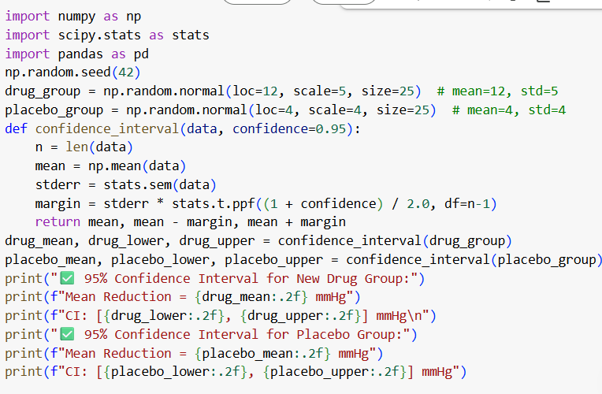 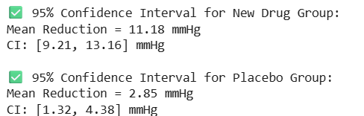

20. **Scenario:**

You are a data scientist working for an e-commerce company. The marketing team has conducted

an A/B test to evaluate the effectiveness of two different website designs (A and B) in terms of

conversion rate.**Question:** "Based on the data collected from the A/B test, is there a statistically significant difference in the mean conversion rates between website design A and website design B?

